**GitHub Project creation:**

1. Sign-up and Sign-in to GitHub <https://github.com/>
2. Click + to select New project
3. Click New Project
4. Provide details of the project

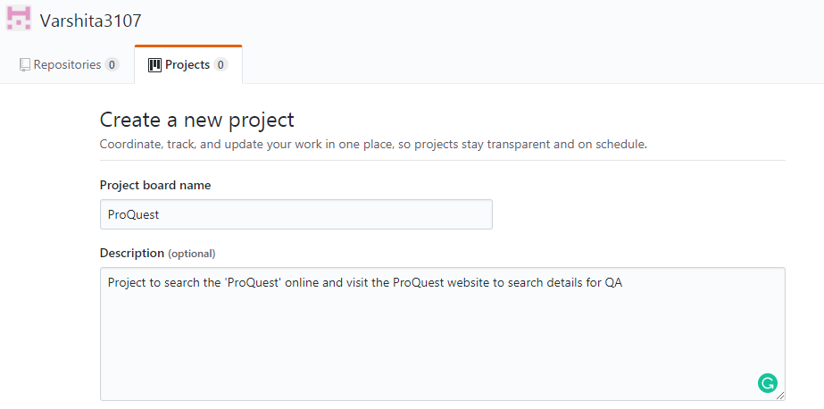

1. Then, click on ‘Create Project’
2. Add the Column

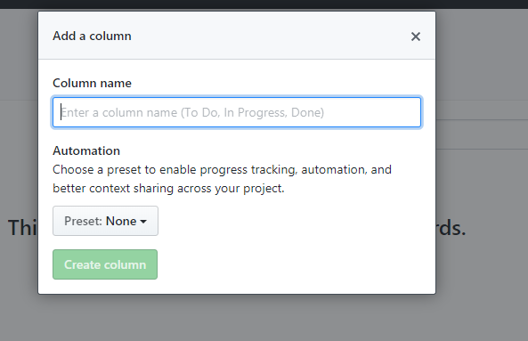

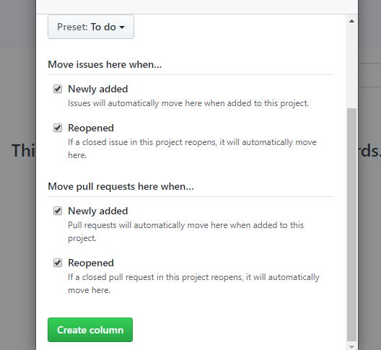

1. GitHub project created

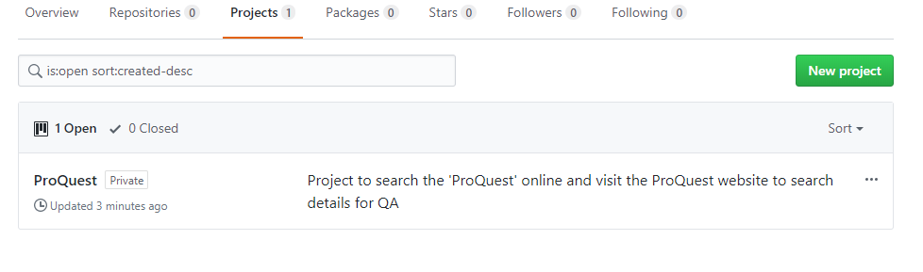

1. Create a Repository by clicking New button

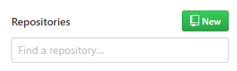

1. Add details for creating new repository and click ‘Create Repository’

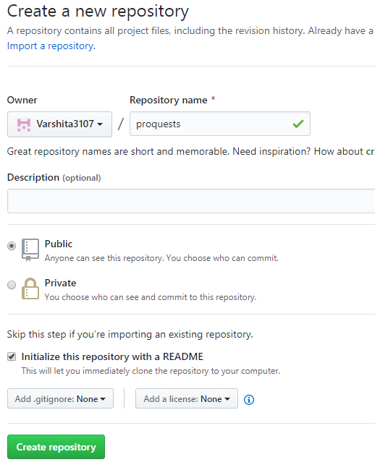

1. It will display the above dashboard and copy the url

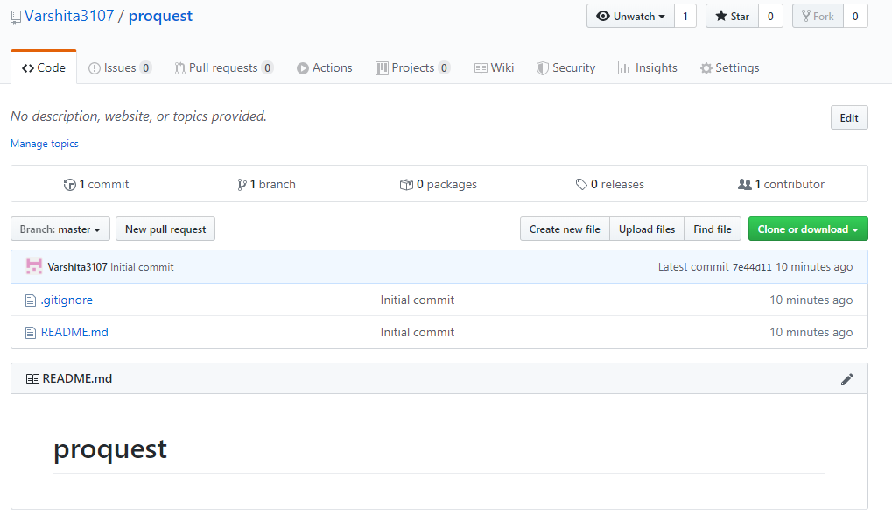

1. Copy the url

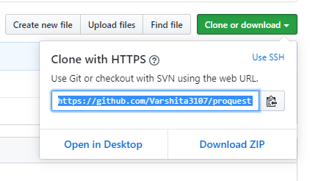

1. Now, go to the git folder location and right click and select ‘Git Bash Here’ to open the command prompt and paste the url as shown

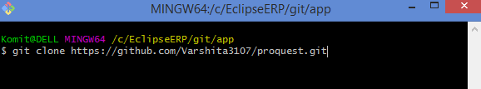

1. Clone the project

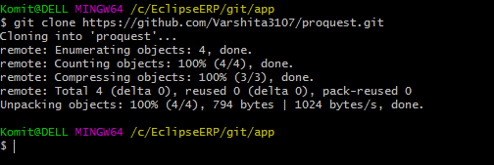

1. Then git add.
2. Git commit -m “Adding the Project”
3. Git push to add all the files are added in Github repository.
4. And use the link to import the Maven project in Eclipse.

Komit@DELL MINGW64 /c/EclipseERP/git/app

$ git clone https://github.com/Varshita3107/proquest.git

Cloning into 'proquest'...

remote: Enumerating objects: 4, done.

remote: Counting objects: 100% (4/4), done.

remote: Compressing objects: 100% (3/3), done.

remote: Total 4 (delta 0), reused 0 (delta 0), pack-reused 0

Unpacking objects: 100% (4/4), 794 bytes | 1024 bytes/s, done.

Komit@DELL MINGW64 /c/EclipseERP/git/app

$ cd proquest/

Komit@DELL MINGW64 /c/EclipseERP/git/app/proquest (master)

$ git add .

warning: LF will be replaced by CRLF in debug.log.

The file will have its original line endings in your working directory

Komit@DELL MINGW64 /c/EclipseERP/git/app/proquest (master)

$ git commit -m "Adding th Project"

[master bffe54d] Adding th Project

15 files changed, 302 insertions(+)

create mode 100644 .classpath

create mode 100644 .project

create mode 100644 .settings/org.eclipse.core.resources.prefs

create mode 100644 .settings/org.eclipse.jdt.core.prefs

create mode 100644 .settings/org.eclipse.m2e.core.prefs

create mode 100644 debug.log

create mode 100644 pom.xml

create mode 100644 src/main/java/com/proquest/proquestapp/App.java

create mode 100644 src/main/resources/Automation Components Installation.docx

create mode 100644 src/main/resources/Automation TestScripts Execution.docx

create mode 100644 src/main/resources/Github Project.docx

create mode 100644 src/main/resources/PQQASimulation.docx

create mode 100644 src/test/java/com/proquest/proquestapp/ProquestMain.java

create mode 100644 src/test/java/com/proquest/proquestapp/search/SearchTest.java

create mode 100644 src/test/java/com/proquest/proquestapp/search/search.feature

Komit@DELL MINGW64 /c/EclipseERP/git/app/proquest (master)

$ git push

Enumerating objects: 32, done.

Counting objects: 100% (32/32), done.

Delta compression using up to 4 threads

Compressing objects: 100% (23/23), done.

Writing objects: 100% (31/31), 1.11 MiB | 771.00 KiB/s, done.

Total 31 (delta 0), reused 0 (delta 0)

To https://github.com/Varshita3107/proquest.git

7e44d11..bffe54d master -> master